Samosas – Lesson 1
Ingredients  100g potato  100g peas  1 onion  25g fresh coriander  1 tsp cumin  ¼ tsp cayenne pepper  1 tblsp oil  Notes  - Don’t forget your apron!  - Check allergies of consumer before serving. | Method  - Dice the potato and simmer for 10 minutes until soft. Remove from the hob and drain off the water. Leave the potatoes to dry and cool.  - Finely dice the onion and coriander.  - Fry in a little oil until soft. Add the cumin and cayenne pepper.  - Remove from the heat and add the potatoes, peas and coriander making sure to mix everything thoroughly.  - Put the filling mixture into a named, blue-lidded Tupperware box and place in the fridge.
Samosas – Lesson 2
Ingredients  1 packet of ready-made filo pastry  2 eggs  Notes  - Don’t forget your apron.  - Plastic container with lid to take home in.  - Check allergies of consumer before serving.  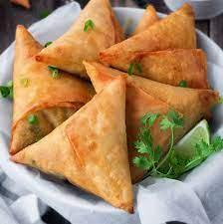 | Method  - Pre-heat the oven 180°C.  - Crack the eggs into a measuring jug and beat with a fork.  - Use a sharp knife to slice the filo pastry into long, 4-inch strips.  - Brush the pastry strip with the beaten egg, then layer 4 strips on top of each other.  - Put a little filling in the corner of one of your filo strips and being to fold the pastry over into triangular shapes until you get to the end of the strip.  - Place each samosa on a baking sheet and lightly brush with beaten egg.  - Bake for 15-20 minutes until lightly golden brown.

