Cheesy pasta
Ingredients  150g (6oz) pasta  Notes  - Don’t forget your apron  - Please bring plastic container with lid to store pasta in.  - Check allergies of consumer before serving. | Method  - Boil a kettle and half fill a saucepan with boiling water and place on a high heat, and bring back to boil.  - Once water is boiling, add the pasta and cook for the required time (stated on the packet) until pasta is soft but not sticky (al dente)  - Strain and place into a plastic container.  - Prepare filling ingredients. Place these in the same container as the pasta.
Cheesy pasta - sauce - lesson 2
Ingredients  50g (2oz) Plain Flour  50g (2oz) Margarine  500 ml (1pt) Milk  100g (4oz) Cheddar Cheese or red Leicester  Notes  - Don’t forget your apronUse skimmed milk and low-fat cheese for healthier version.  - Please bring 2 litre ovenproof dish to take home in and cook in (with a lid or foil to cover)  - Check allergies of consumer before serving. | Method  - Grate the cheese  - To make sauce place the milk mixture into the saucepan  - Bring to boil slowly, stirring continuously until the sauce is thick and glossy.  - Remove from the heat and add half of the grated cheese. Stir until the cheese has melted.  - Add pasta and filling ingredients to the sauce and stir until pasta is coated, place in serving dish.  - Sprinkle with extra cheese  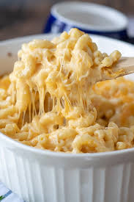  - Place under a high grill for 5-10 mins until golden brown.

