Links for reading for pleasure
Use the AMS Library Web app for suggestions; you can visit as Guest if you can’t log in.
Borrow from the public library online (BorrowBox): you can download ebooks and audiobooks directly, and reserve books to collect (Click and Collect service).
Audible has made a range of audiobooks freely available during lockdown.
You can find free scans of books at Project Gutenberg https://www.gutenberg.org/ .
The LibraryLady blog has an updated post with links to many sites and individual authors, whether you love Emma Carroll or want to learn to draw with Jim Field (author of Oi Frog!).

Online resources to expand your world!
(With thanks to Forest Hills School Library)

Art and History
 | Explore Google Arts and Culture:  - Google Cultural Institute – see works of art in exquisite detail, zoom in to see individual brush strokes!  - Google History Project – get up close to historical events and objects  - take a tour of great world museums  - find unusual fun activities
 | Find book-related activities , and  browse old maps, sound recordings and original books in the British Library’s digital collection- including Leonardo da Vinci's notebook, and Jane Austen's early work in her own handwriting.
 | Tour the British Museum from home, and search unusual objects in the collection. There are Young Explorers’ trails for KS2
Music
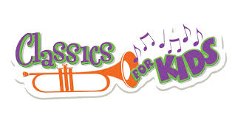 | Explore music in games, and find out about orchestras and instruments. (Cincinnati Public Radio)
Science and engineering
 | Home school challenges for Polar expeditions
 | Enjoy lively science videos from the SciShow Youtube channel including CoViD-19 information (US site)
 | Visit Discover (Oxford University) and explore videos, experiments to do at home, and podcasts. Or explore NASA’s journeys
Wildlife – in Dorset and worldwide
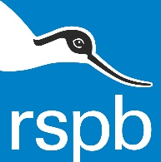 | https://www.rspb.org.uk/birds-and-wildlife/wildlife-guides/natures-calendar-january/  What birds can you see around you?
 | Brownsea Island webcam
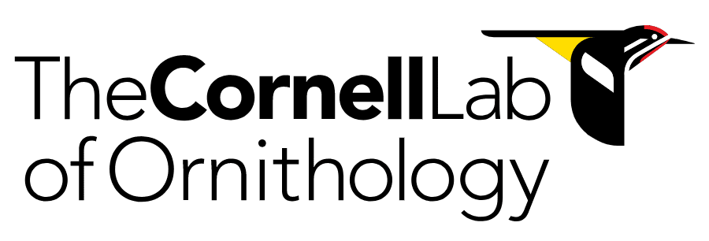 | The Cornell Lab is a world leader in the study and conservation of birds. The cam page is particularly interesting.
Touch-typing – a skill for life!
 | - Typing Club: good home learning course to learn to type on a keyboard.
Interested in languages?
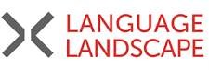 | - Language Landscape: mapping where languages are spoken around the world. Click on the markers to hear recordings of languages spoken in those locations.
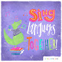 | - Babel Babies: Children’s songs in a variety of languages

